“AIRLINE RESERVATION SYSTEM”

A
Project Report
Submitted towards the partial fulfillment of
requirements for the award of

Diploma
in
Computer Engineering

Submitted by:
Paras Aggarwal
13001080031

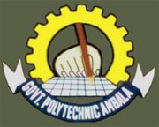
(2013–2016)

Department of Computer Engineering
Government Polytechnic, Ambala City
(Affiliated to State Board of Technical Education, Haryana)

